# IICT6203 - Database Programming II

## Worksheet 05 - Triggers

1. Create a function that accepts a year, and returns a table with the year, product id, total amount (euro) of each product sold per year, and total quantity of each product sold per year as well. Name the function udf_ReturnStats.
2. Test the previous function with year 2016. Compare your result with the following result.

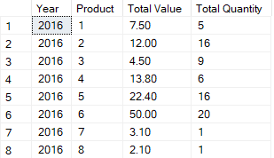

1. Create a procedure that accepts a date as a parameter. The procedure must create a new order, and insert it in the order table. It must return the order id. Name the procedure usp_InsertOrder.
2. Create a procedure that accepts an order id, a product name and the quantity. These must then be inserted in the Order List table. Name the procedure usp_InsertOrderItem.
3. Create a trigger on the table OrderList that fires after an insert. It should deduct the stock in the Product table per product inserted in OrderList. Name the trigger trg_ProductQuantity.
4. Create a trigger on the table Order that fires after an insert. Its logic is as follows:

* If the last order inserted has a different year that the last existing order
  + Generate the statistics using the function created in Q1 and insert the resulting statistics in the Statistics table.

1. Testing:

* Insert a new order happening in 2017-01-01. The order consists of 3 Table Water, and 5 Nachos.
* Select all the data from the statistics table and it should match the following output:



